1. **Solutions description**

* Developed using VS 2019 and .net core 3.0
* Clone the repository using the command `git clone <https://github.com/nadeem-nasir/Crayon.Exchangerates.git>
* Open `Crayon.Exchangerates.sln` and wait for Visual Studio to restore all Nuget packages
* Build and Run

1. **How to make request using Postman**

* Request and response in Postman

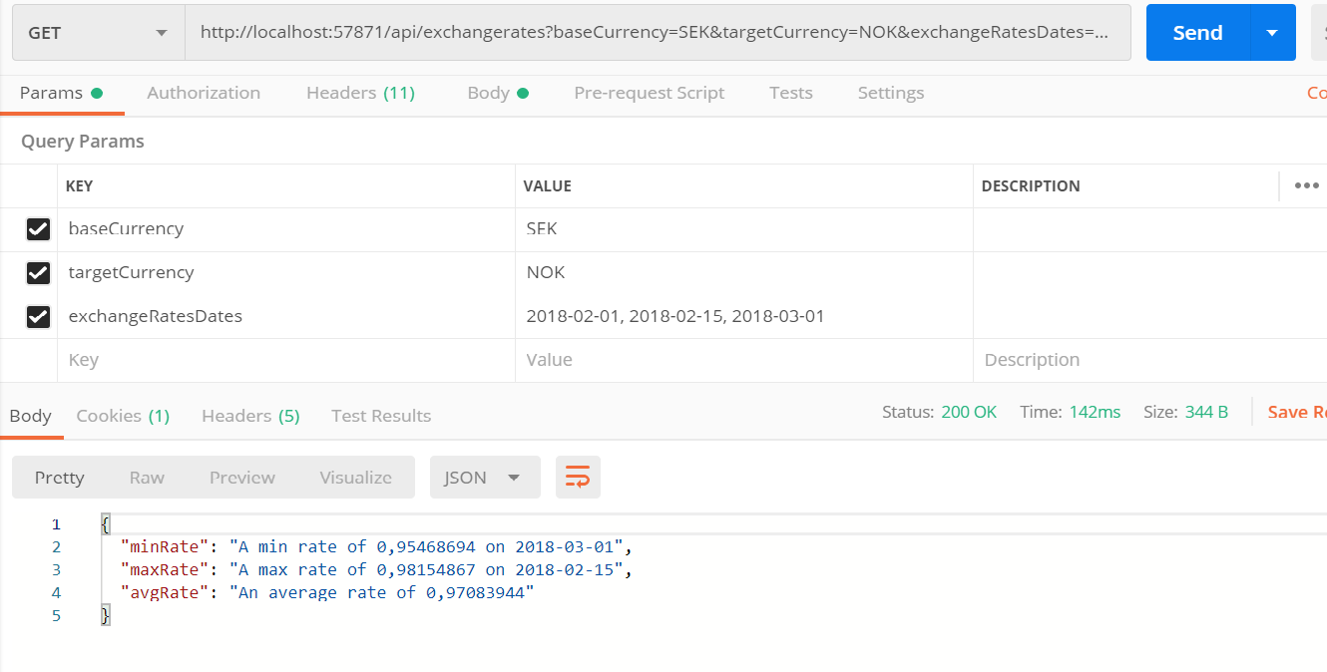

1. **How to make request Swagger**

* Request in swagger

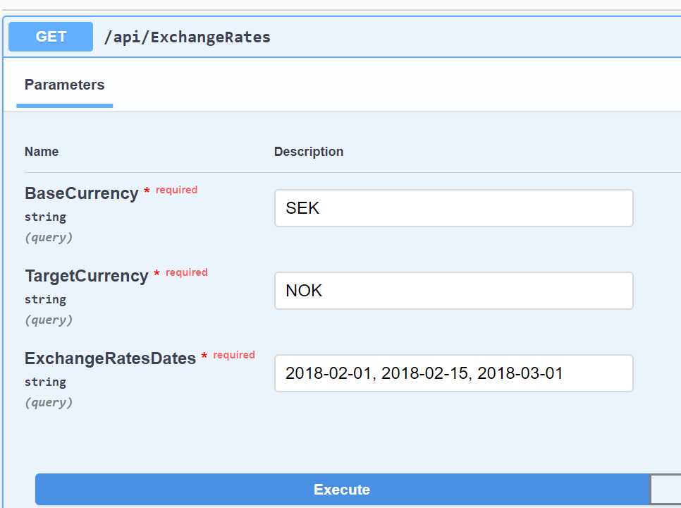

* **And response in swagger**

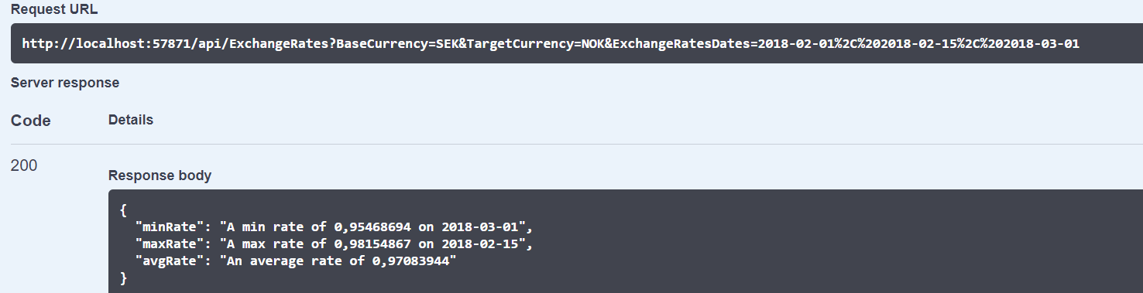

1. **Shortcuts or known issues**
   * No validation for currency codes. It will be possible that user enter currency code that does not exist
   * Passing parameters using query string and it will be possible that URL exceed the maximum allowed length
   * No unit or integration testing